Dwelling in the Enfolding
an immersive 360-degree audio visual artwork
by Matthew Burtner (sound) and Mona Kasra (visual media)
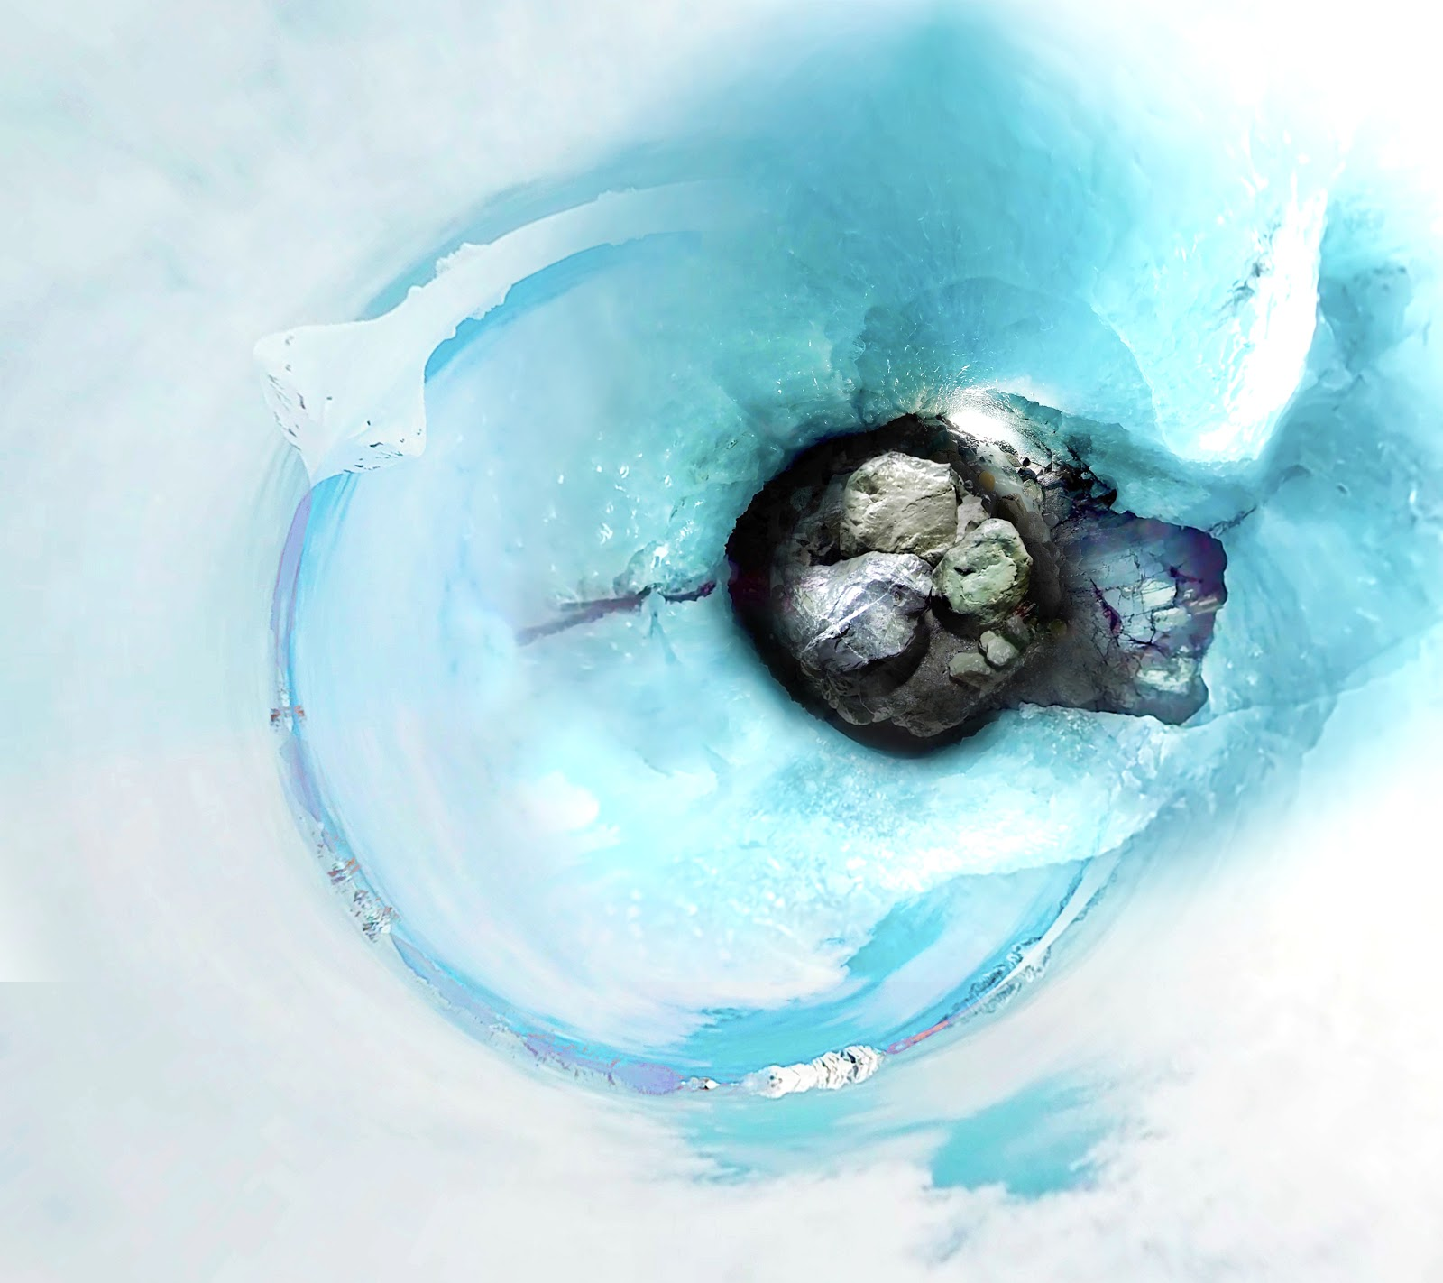

Description:

Dwelling in the Enfolding (2020) is an immersive audio-visual environment of interconnected landscapes that were never inhabited yet are able to inhabit imaginations – moving landscapes so vast, so confident, and so subdued, they almost seem stationary and eternal. The surrounding stillness, however, continues evolving while each landscape, in its perpetual act of dwelling, devoid of human life, reminds us of an intertwining past, present, and future.

To perceive this landscape is to grasp what is not humanly perceivable, and the landscape thus resists our comprehension. Neither our individual nor our collective memories and experiences are ascribed to the tapestry of this space. We don’t belong here; and through the work we recognize our sheer inability to grasp the temporal and spatial scale of the landscape and the dynamic relational forces affecting it.

Nevertheless, the landscape dwells everywhere within itself, in a constant state of inter-animation and transformation. In this landscape, water turns to clouds turns to snow turns to ice turns back to water. Layer upon layer, these complex entanglements flow above, beneath, and through the obscure surfaces of the landscape concurrently, eroding and shaping the land and the underlying rocks. Far beyond the limits of our human perception, the landscape enfolds itself to reveal the hidden, the obscure, the wonderment.

Utilizing 360 spatial sound and video, this piece encourages viewers to inhabit virtual landscapes and bridge across seeming disparate areas that in fact belong to a unified whole.

Bios:

Matthew Burtner (www.matthewburtner.com) is an Alaskan-born composer, eco-acoustician and sound artist whose work explores embodiment, ecology, polytemporality and noise. His ecoacoustic music has been featured by NASA, the Center for Energy Studies in the Humanities (CENHS) at Rice University, PBS NewsHour, the Humanities Center at the University of Michigan, the American Geophysical Union (AGU), the U.S. State Department under President Obama, and National Geographic. He published three intermedia climate change operas about Alaska including the IDEA Award-winning work, Auksalaq. Burtner’s music has also received honors and awards from the Bourges (France), Gaudeamus (Netherlands), Darmstadt (Germany), and The Russolo (Italy) international competitions. He is Eleanor Shea Professor of Music at the University of Virginia (www.virginia.edu) where he Co-Directs the Coastal Future Conservatory (http://www.coastalconservatory.org). He also directs the environmental music non-profit organization EcoSono (www.ecosono.org).

Mona Kasra (www.monakasra.com) is an Iranian-American new media artist and interdisciplinary scholar. Her research focus involves exploring the confluence of media technologies, art, and culture, reflecting on the impact of emerging media on personal, political, and creative expression, and experimenting with the affordances of such media for artistic and performative practices. Committed to transdisciplinary and collaborative modes of scholarship, she's currently researching representational, affective, and creative possibilities of immersive media and designing experimental and performative environments in Virtual Reality. She's Assistant Professor of Digital Media Design at the University of Virginia.
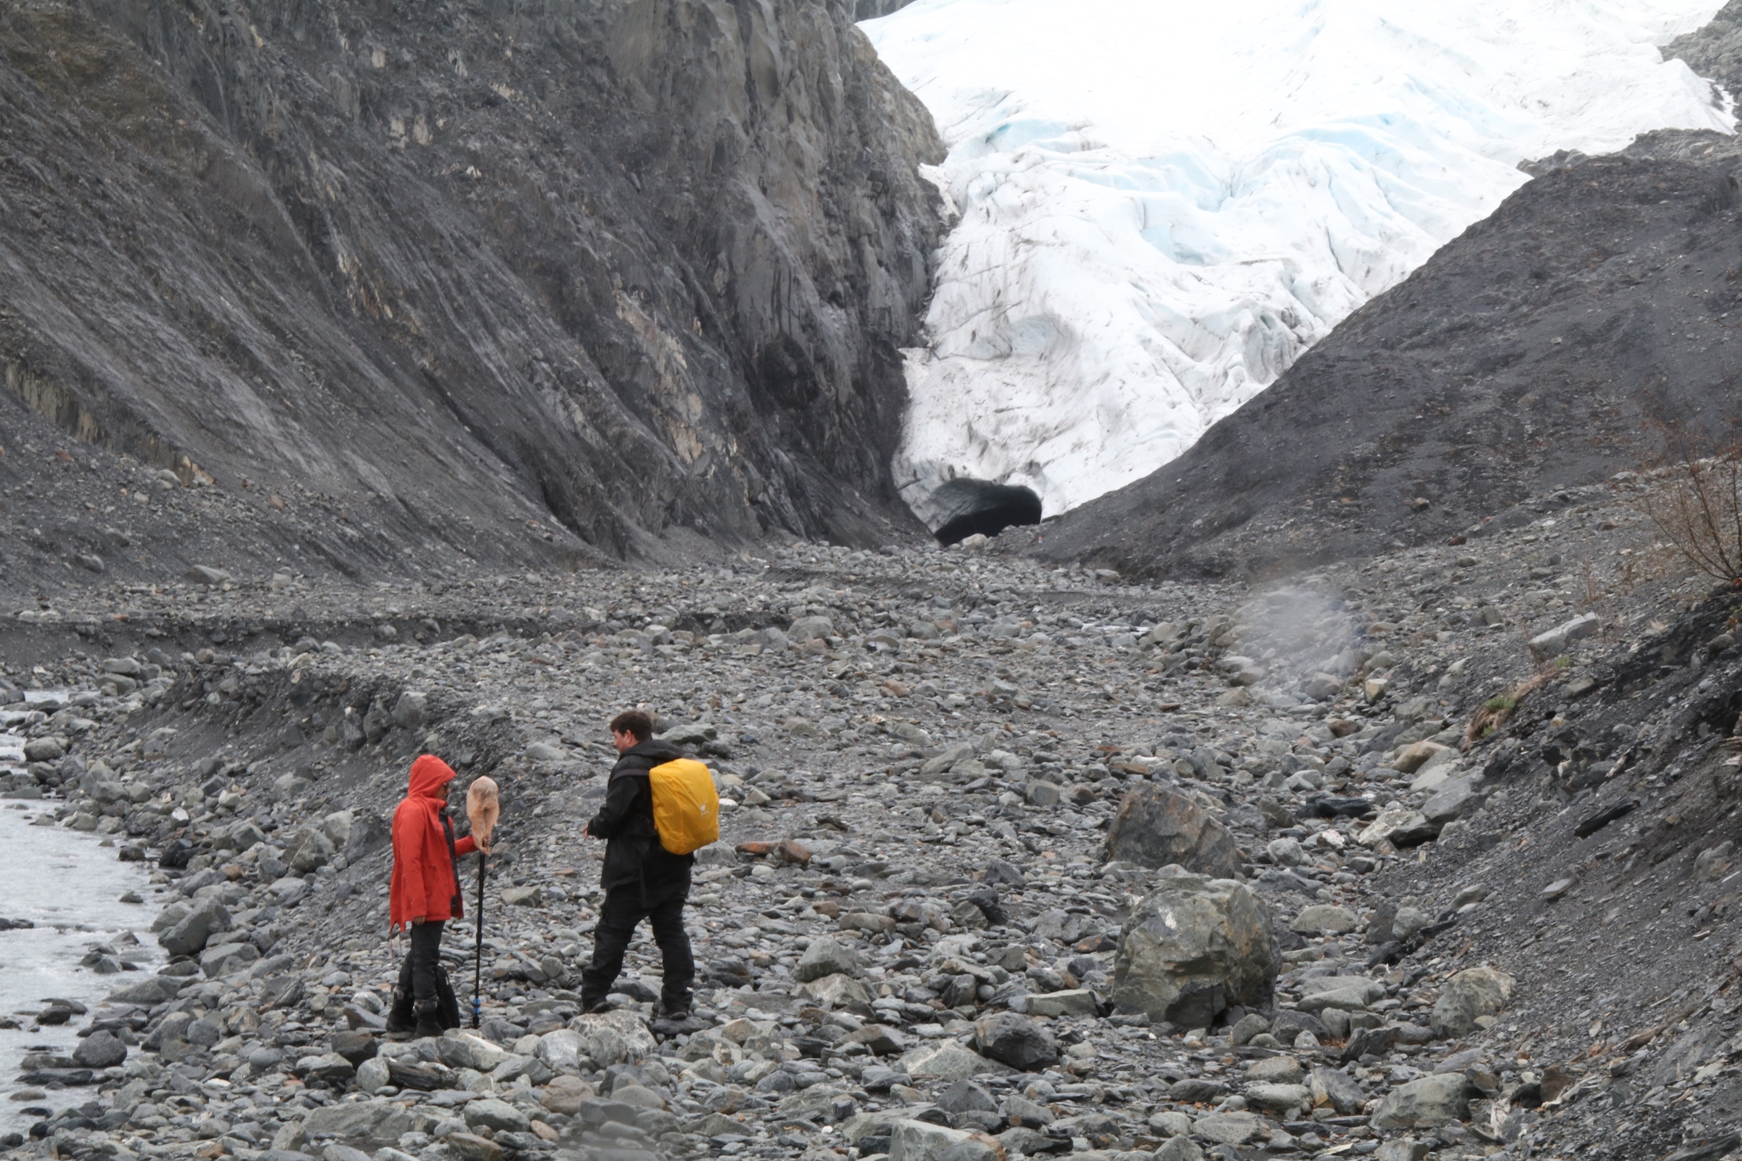
Mona and Matthew conduct fieldwork in Alaska to create Dwelling in the Enfolding

