A large-scale participatory sound art project creating a sonic experiential glacier
Created by Matthew Burtner and Matthew Duvall

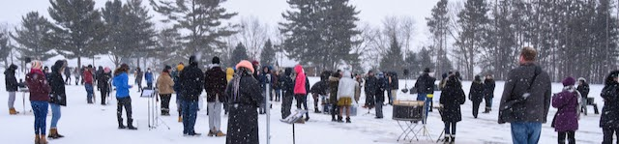
A performance of Transient Landscapes at the Interlochen Center for the Arts, February 2020

“People have this misconception that glaciers are silent expanses, landscapes frozen in time. But they’re not, at all. They’re a species of incredibly noisy animals, and they’re facing extinction.”
- Matthew Burtner

Fossil fuels deep in the earth become atmosphere, a glacier becomes the floodwater in a basement on the other side of the world, coasts become the sea and the sea becomes plastic. We live in an era of Transient Landscapes, the frequency and intensity of our eroding environment amplified by humans through compounding impacts we barely understand. Through creative sound art and ecoacoustics, Transient Landscapes connects the human imagination to the environment.
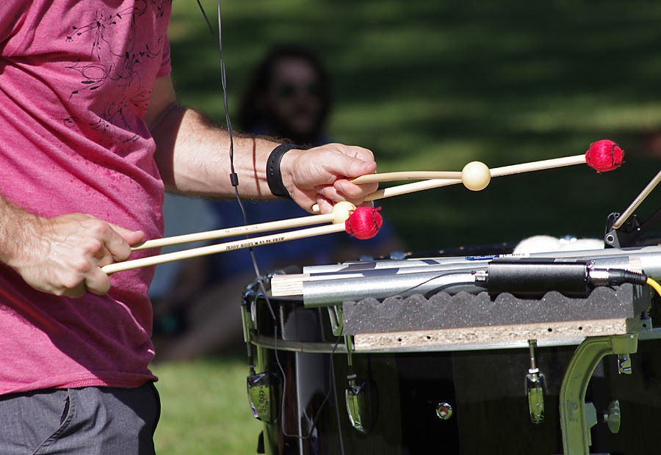
Transient Landscapes, Sarasota, October 2018

Transient Landscapes is a fully immersive performance sound artwork for glacier ecoacoustics, percussionists, three groups of participants, audience participation, and amplified field recordings exploring sound as a means of tracking, interpreting and remapping climate change into sound art. Through their actions, participants connect to one another and the work itself by joining nodes of the sonic glacier cast. Moving around the space as if traversing the glacier itself, the public illuminates the experience of the singular and collective body, the relationship between the glacier and the human, connected across the world.

Percussionist/Curator, Matthew Duvall and Eco-Acoustician/Composer, Matthew Burtner combined the ephemeral presence of sound with the material quality of a glacier to create a large-scale performance installation. Matthew Burtner’s ecoacoustic research on the Alaskan glaciers and computer analysis of his own multichannel tidal glacier “sound casts” form the foundation of the work.
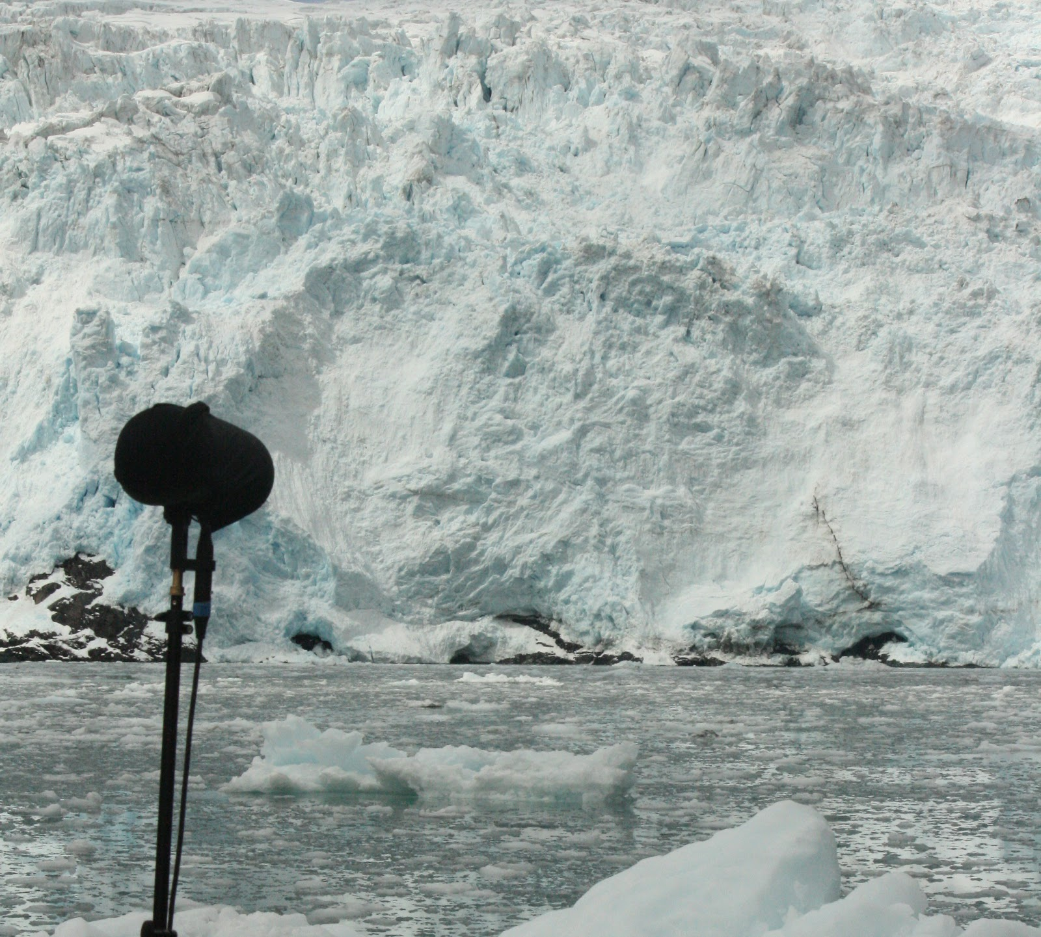
Transient Landscapes is created by five groups of performers representing glaciers, tides, melt, introspection, and transience. Minimum participation requires 48 performers (not including the audience, which also plays a role). Transient Landscapes can accommodate, and can be much more impactful, with significantly larger participation.

Education

Transient Landscapes can be complemented with a wide range of educational opportunities. The applied experience of engaging with a performance of Transient Landscapes is deeply enriched by preparatory exposure to topics such as climate science, glaciers, protest art, government policy, geology, in addition to studies in the arts disciplines. This can be accomplished through a range of planned activities such as incorporating performance participation into class syllabi and featuring relevant special topics led by faculty, guest speakers, or representatives from local environmental action organizations. These don’t need to be expensive ventures. Local specialists engaging with audiences can, and should, focus attention on local environmental issues and impacts.

A performance of this type helps academics reach new audiences. Academic research is important and would benefit from reaching the public, but often it gets caught in a closed information loop (academic journals, students, academic conferences, etc.). A project like this provides a unique opportunity to reach a large, non-academic audience at a single encounter. Humans are moved more by feelings than by information. This performance creates a bridge, helping the public feel climate change.

“We could marvel at the patterns and variety of pitch, tone quality and rhythm and let go of the need to evaluate each segment…” - Sarasota Herald Tribune, World Premiere, Oct 20, 2018
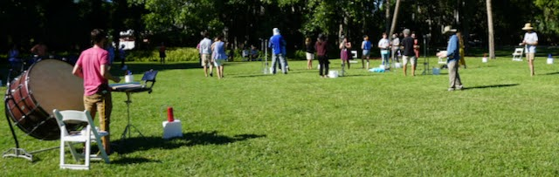
Transient Landscapes performance at the Ringling Museum in Sarasota, Florida

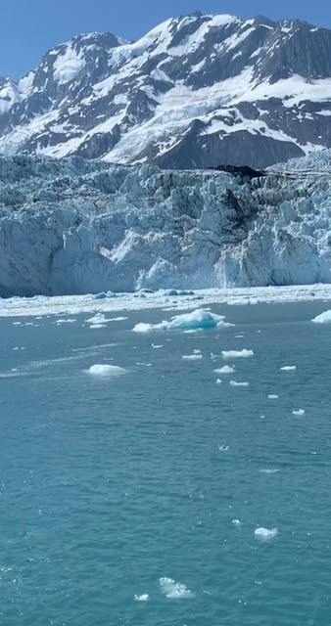
Ecoacoustics

Matthew Burtner describes his body of work as Musical Ecoacoustics and defines the discipline as follows:
“Musical Ecoacoustics embeds environmental systems into musical and performance structures using new technologies. Ecoacoustic music derives methodology from abstracted environmental processes, remapping data from the ecological into musical domain. It draws on techniques of sonification and soundscape composition (Truax, Westerkamp, Keller and others). The data from nature may be audio information (from wind or ocean waves for example), or it may be some measurable parameter such as temperature, geological change, etc. Going beyond direct sonification, I develop a syntax on the basis of the recorded natural processes, and create new patterns conforming to this syntax. My interest in ecoacoustics arises from my experiences growing in the Arctic of Alaska, on the fishing boats on Alaska’s Southwest coast, and in the mountains above Anchorage. Snow, ice, wind and sea figure prominently in my work. I developed ecoacoustic techniques in works such as Mists (1995) for stones and noise, and Sikuigvik (the time of ice melting) (1997) for piano and large ensemble in which the process of ice melting is used as a musical form. The technique came to fruition in the first of my large-scale Alaskan opera/theater pieces, Ukiuq Tulugaq (Winter Raven) (1999-2002), in which systems of snow, wind and climate generate musical form and material.”

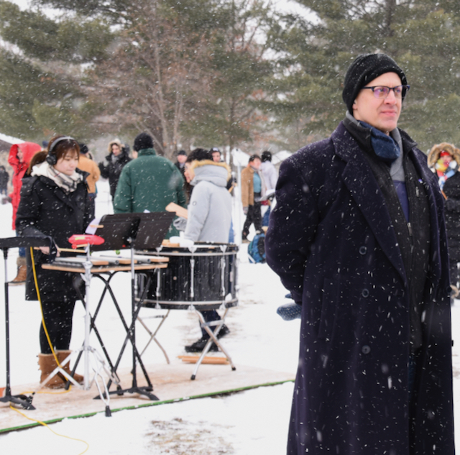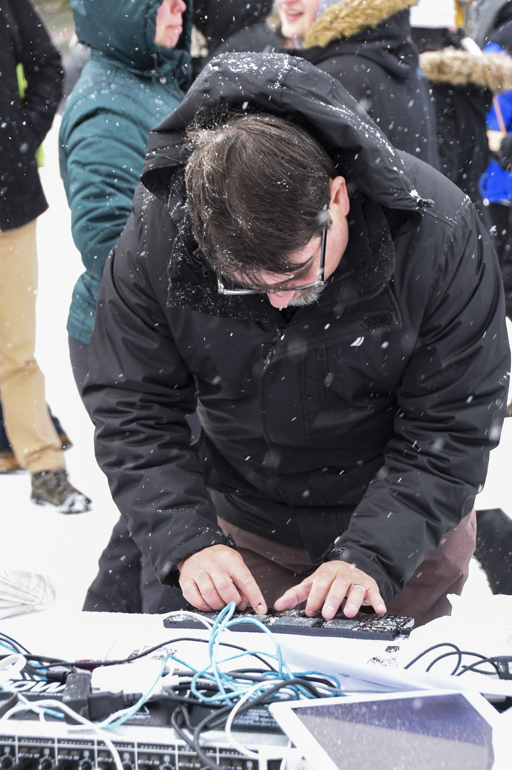
Matthew Duvall with Glacier Performer in the Background. Matthew Burtner Performing Introspection

“The experience of collaboratively creating a sonic glacier forms a community of people who come to realize that they have created something together. Through this shared experience they become indelibly connected to that time and place.” - Matthew Duvall
Performance Notes
As the performative concepts of Transient Landscapes can seem abstract prior to direct involvement, here are a few clarifications:
- This is a large-scale performance experience. A minimum of 48 performers is required.
- There are five (5) groups of performers: Glaciers, Tides, Melt, Introspection, and Transience
  - Glacier performers are percussionists each with an instrument configuration incorporating wooden planks, metal pipes, and two drums, realizing field recordings of water run-off and calving events
  - Tide performers walk the paths across the immersive performance space and play wooden planks with mallets to emulate the friction of ice the popping release of compressed air, the sounds of ebb and flow tides as glacial ice migrates out to sea and then back again
  - Melt performers play tuned pipes submerged in water to create bending effects suggesting the concept of ice melt
  - Introspection performers play small midi keyboards, a drone-like canvas of contemplative music
  - Transience performers walk the space randomly, introducing the interruptive behavior of human impact Ice Collecting at the Face of a Tidal Glacier
- Everyone in attendance has the opportunity to additionally participate by streaming glacier field recordings from their mobile devices
- All tuned wooden planks and metal pipes will be provided
- Four (4) of these groups require rehearsal. The Glacier group should rehearse together in advance. The other groups will have their parts explained to them in rehearsal and do not require preparation in advance of the main rehearsal.
- One of those groups, the Tides, requires a critical mass of performers, preferably a minimum of 35 performers. This is not a cap. Many more than 35 Tide performers are welcome.
- Performing most of the parts in this piece does not require musical training. This is a broad performance experience, and participation is not limited to an area of specialization. A truly collaborative experience involves people from many walks of life.
- The performance space is fully immersive. There is no hurried activity. All movements through the space are calm and relaxed. We all gently flow among one another.
- And Yes, It is fine to come and experience the performance as an audience member! Come!

Sample Preparation Schedule
- Pre-Performance Date
  - Rehearsal for the Glacier Performers (3hrs recommended)

- Performance Date
  - 1.5hrs, Setup
  - 30min, Arrivals Window
  - 1hr15min, Rehearsal 1
  - 15min, Break
  - 1hr, Full Dress Rehearsal
  - 1hr, Meal Break
  - 1hr, Performance
Samples of performance materials follow. Please note that the materials are often revised for site specificity. These materials are for example purposes only and may not be precisely what is provided for a particular performance.

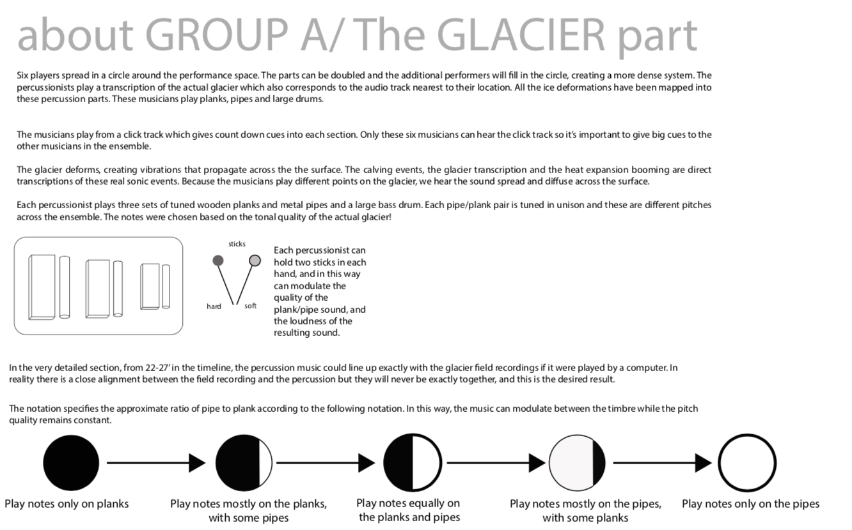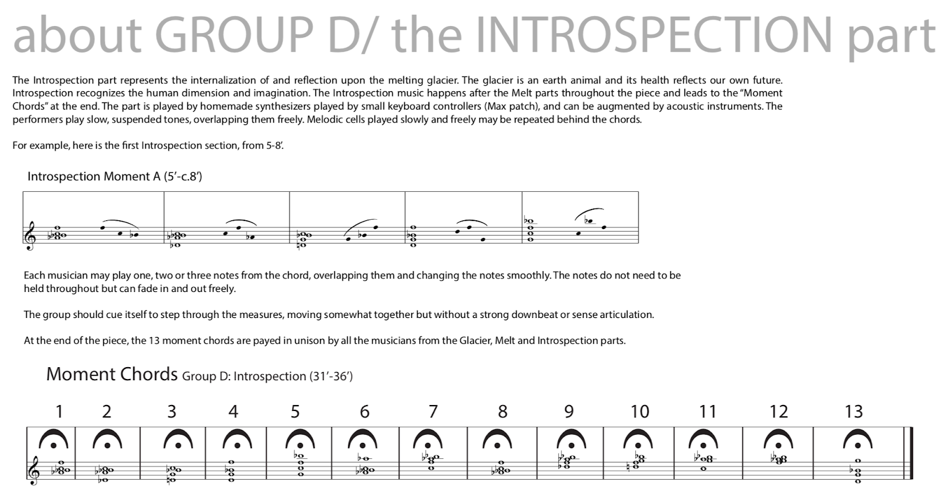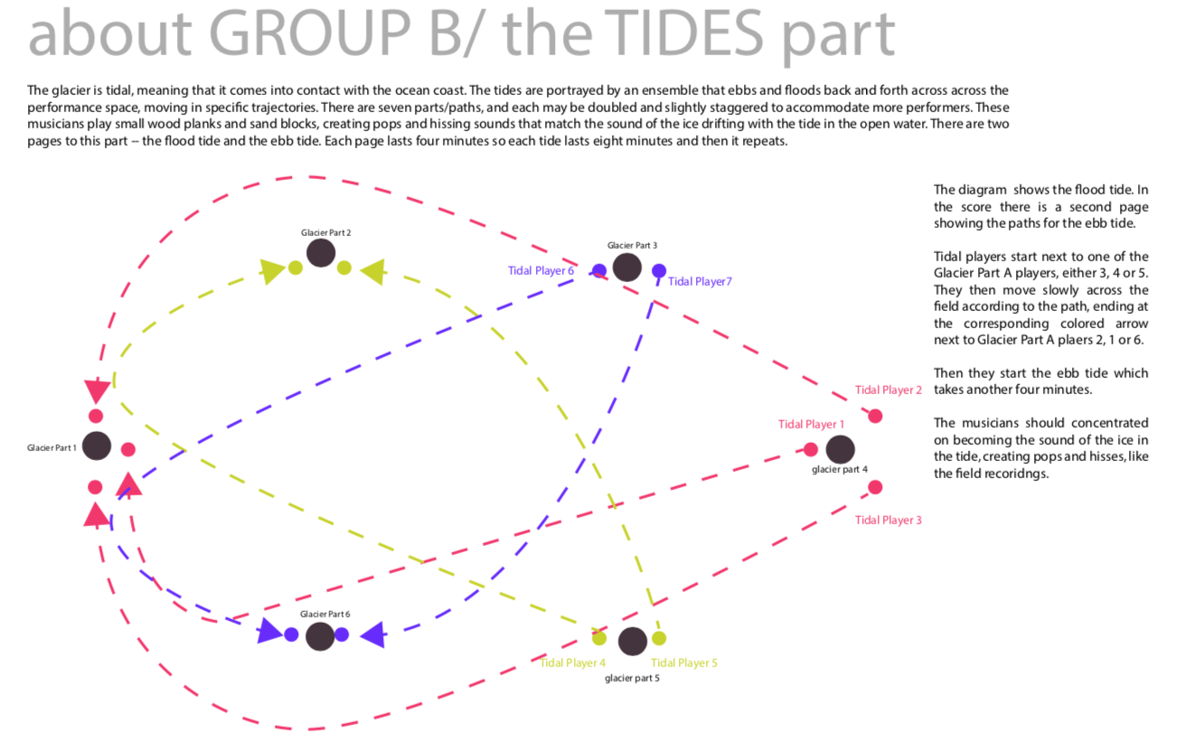
Sample Stage Plot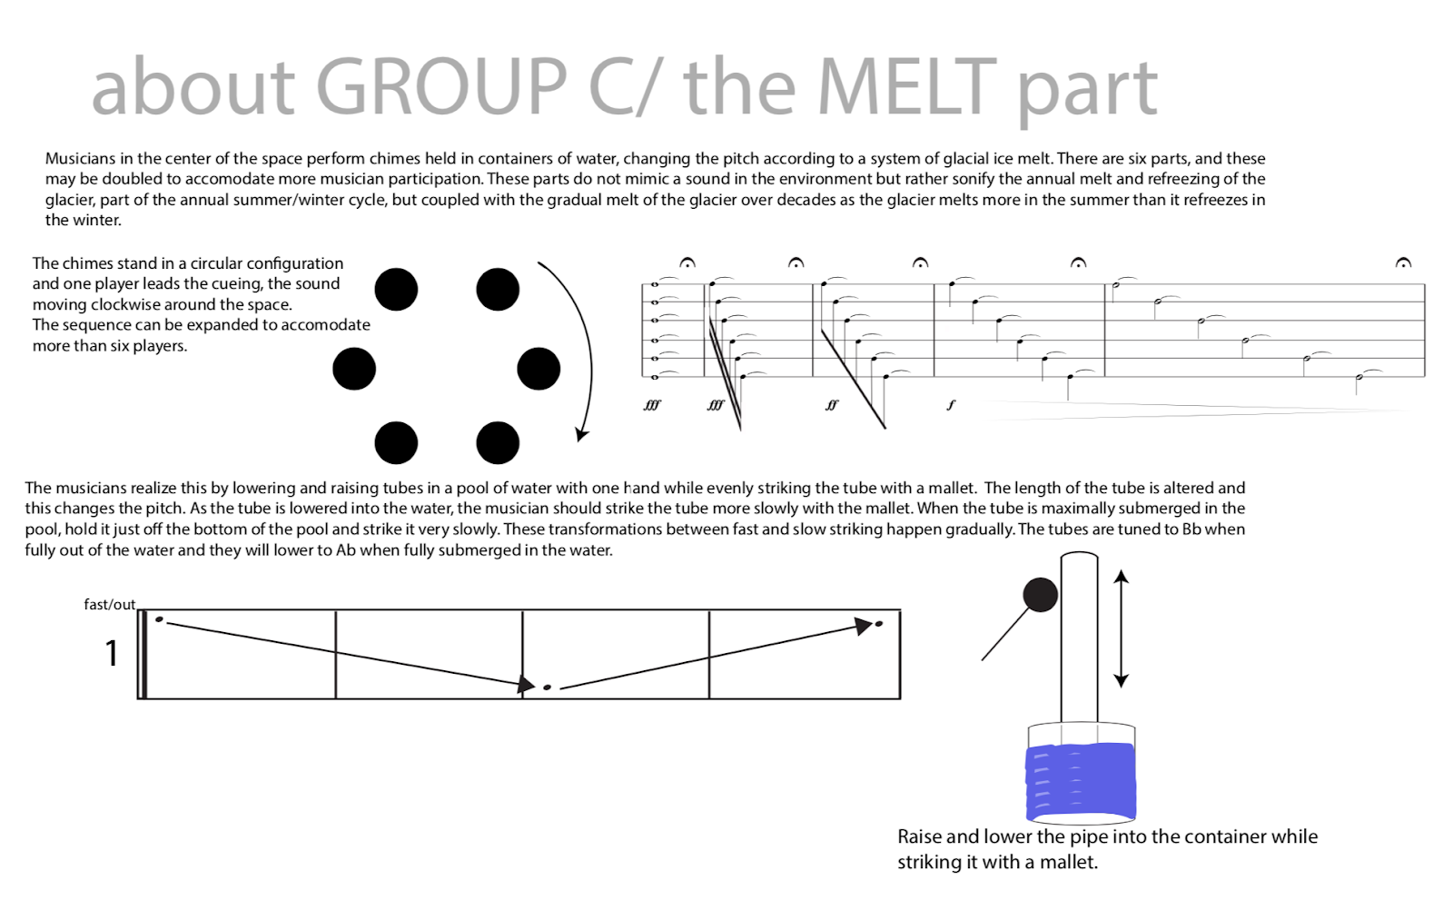
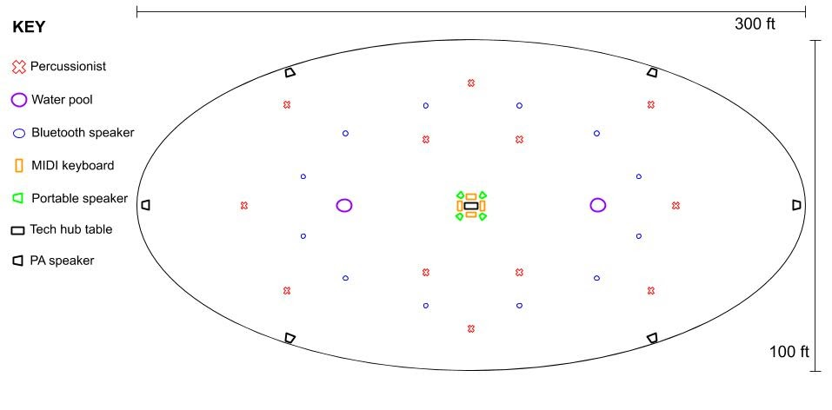

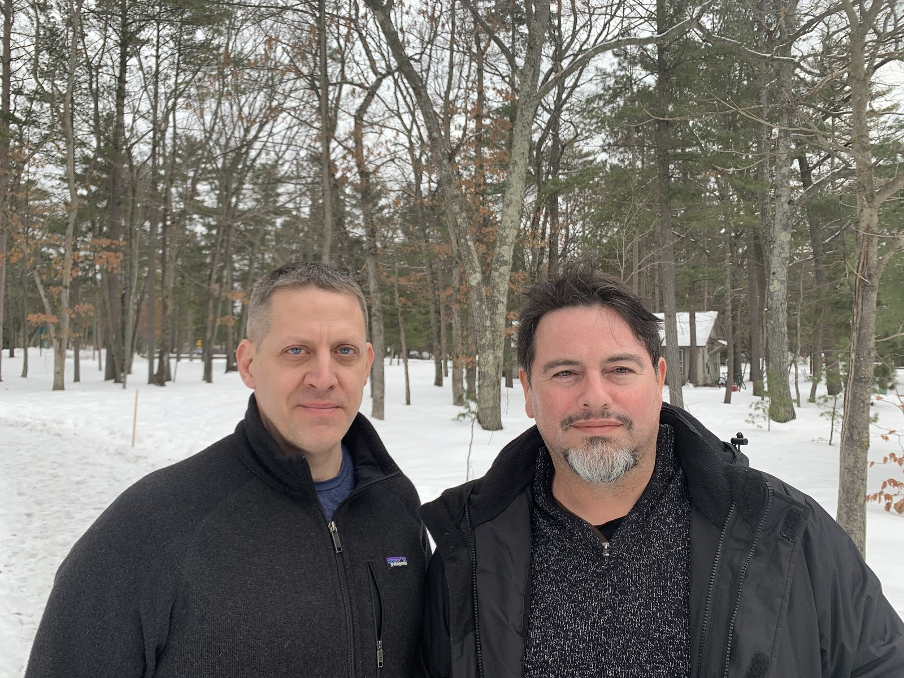
Project Creators, Matthew Duvall and Matthew Burtner
Bios
Matthew Duvall is a founder, co-Artistic Director, and percussionist of Eighth Blackbird. Four Grammy awards, the MacArthur Award for Creative and Effective Institutions, Musical America Ensemble of the Year 2016, Chamber Music America Visionary Award 2016, competition wins with Concert Artists Guild and the Naumburg Foundation. Recording catalogue with Cedille records. Matthew proudly endorses Pearl Drums and Adams Musical Instruments, Vic Firth Sticks and Mallets, Zildjian Cymbals, and Black Swamp Percussion Accessories. More information can be found at www.eighthblackbird.org.

Matthew Burtner (www.matthewburtner.com) is an Alaskan-born composer, eco-acoustician and sound artist whose work explores embodiment, ecology, polytemporality and noise. In addition to working with ensembles, artists and arts organizations, his work has recently been featured by NASA, PBS NewsHour, the Humanities Center at the University of Michigan, the American Geophysical Union (AGU), the U.S. State Department under President Obama, and National Geographic. Matthew’s music has received honors and awards from the Bourges (France), Gaudeamus (Netherlands), Darmstadt (Germany), and The Russolo (Italy) international competitions. He directs environmental music non-profit organization EcoSono (www.ecosono.org) and serves as Eleanor Shea Professor of Music at the University of Virginia (www.virginia.edu) where he Co-Directs the Coastal Future Conservatory (http://www.coastalconservatory.org).

